OU Analyzer

# Overview

OU Analyzer fetches all the Organizational Units from Active Directory instance along with their Users and User Groups.

# Goal

It is prepared to ease out the process of analyzation of Organizational units on daily basis by getting the report over mail in a simple, CSV format.

# Solution/Logic Design

Fetch all the OUs

ou.OrganizationalUnits

Organizational units(ou)

For each ou fetch its users and userGroups

Get users.length

Array.push(ou name,users,userGroups,users Count)

Write data to the file with the action “write dataToTheFile” and send the file with the mail through workflow “send mail”

end

# OU Properties

* OU – organizational unit or business group within a container.
* Users – users within that organizational unit
* User Groups – User group within that organizational unit
* Number of Users – total number of users in that organizational unit.

Dependencies

# Related Actions

* WriteDataToTheFile – It writes the requested data to the file.
* ValidateEmail – It validates the email address.

# Related Workflows

* Send Mail – It attaches the file to the mail and send it to the specified requester.

# Related Configuration elements

* fromName – Sender’s Name
* fromAddress – sender’s Address
* smtpHost – with which one will be able to connect to the server to send the mail.
* CcAddress – it includes other member’s mail address to whom requester wants to send the mail.
* smtpPort - with which one will be able to connect to the server to send the mail.
* Ou – Organizational unit

# Attributes

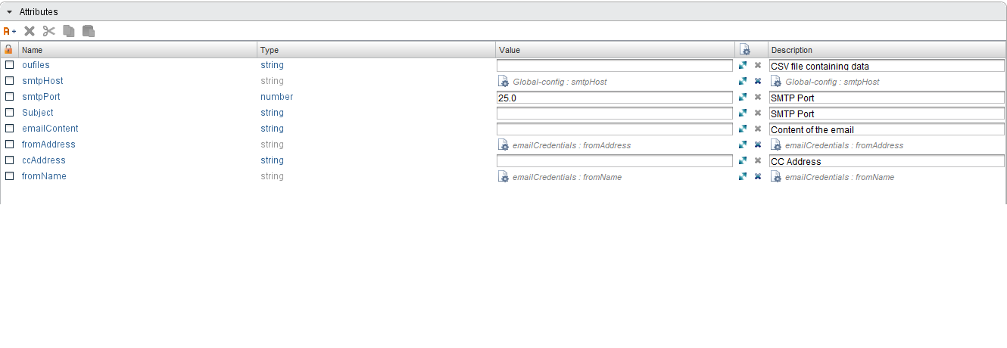

# Inputs

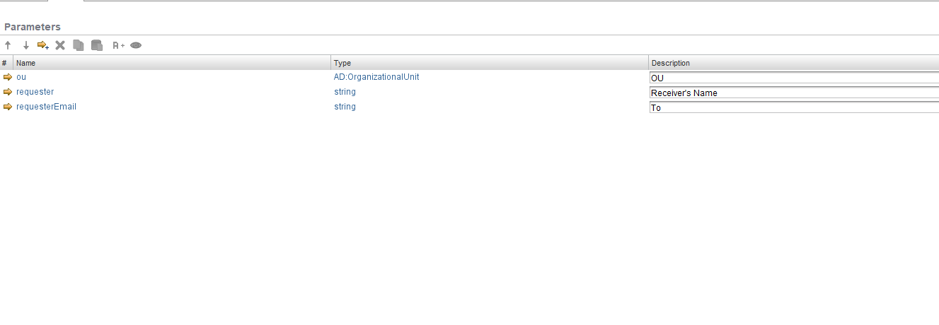

# Future Scope

It can be extended to:

* Fetch OU, user Group and users filtered on several aspects.